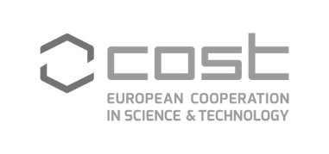
University of Porto, Porto, 29/06/2017

COST Action CA16101
MULTi-modal imaging of FOREnsic SciEnce Evidence - Tools for Forensic Science

Getting to know each other and Round Robin Study (RRS)

Chair of the Action: Dr. Simona Francese (UK)
Vice Chair of the Action: Prof. Massimo Tistarelli (IT)
Working Group 1 Leader: Dr. Manuel Algarra (ES)

WG1 – Best Practice Guidelines for application of imaging protocols /
technologies (Analytical Strand)

Meeting Program

08:30 - 09:00 Welcome and housekeeping matters. Presentation of Actions' Objectives for this meeting

09:00 - 10:30 Getting to know each other - "What we are and do" in 3 minutes pptx presentation.

10:30 - 11:00 Break

11:00 - 12:15 Planning the RRS:

- Forensic evidence ?
- Techniques?
- Single modal versus multi modal?

12:30 - 13:30 Lunch

13:30 - 15:30 Round Robin Study session and discussion

- State of the art of techniques in relation to sensitivity, robustness, versatility, compatibility, etc.
- Identification of the technologies to be investigated
- How to enhance the value of the Forensic Evidence
- Interaction between groups

15:30 - 16:00 Break

16:00 - 16:30 Final drafting of the RRS and action plan.

