MULTIFORESEE Training School (CA16101)
Operational CSI and Imaging Techniques -
Scope, programme and Application form
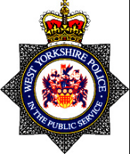

Delivered by West Yorkshire Police & Regional Scientific Support Services
Yorkshire and the Humber CSI Training Team

MULTIFORESEE Training School
Operational CSI and Imaging Techniques 21-25 Aug 2017
Location: West Yorkshire Police Training and Development Centre
Carr Gate Complex
Bradford Road
Wakefield WF2 0QD
United Kingdom
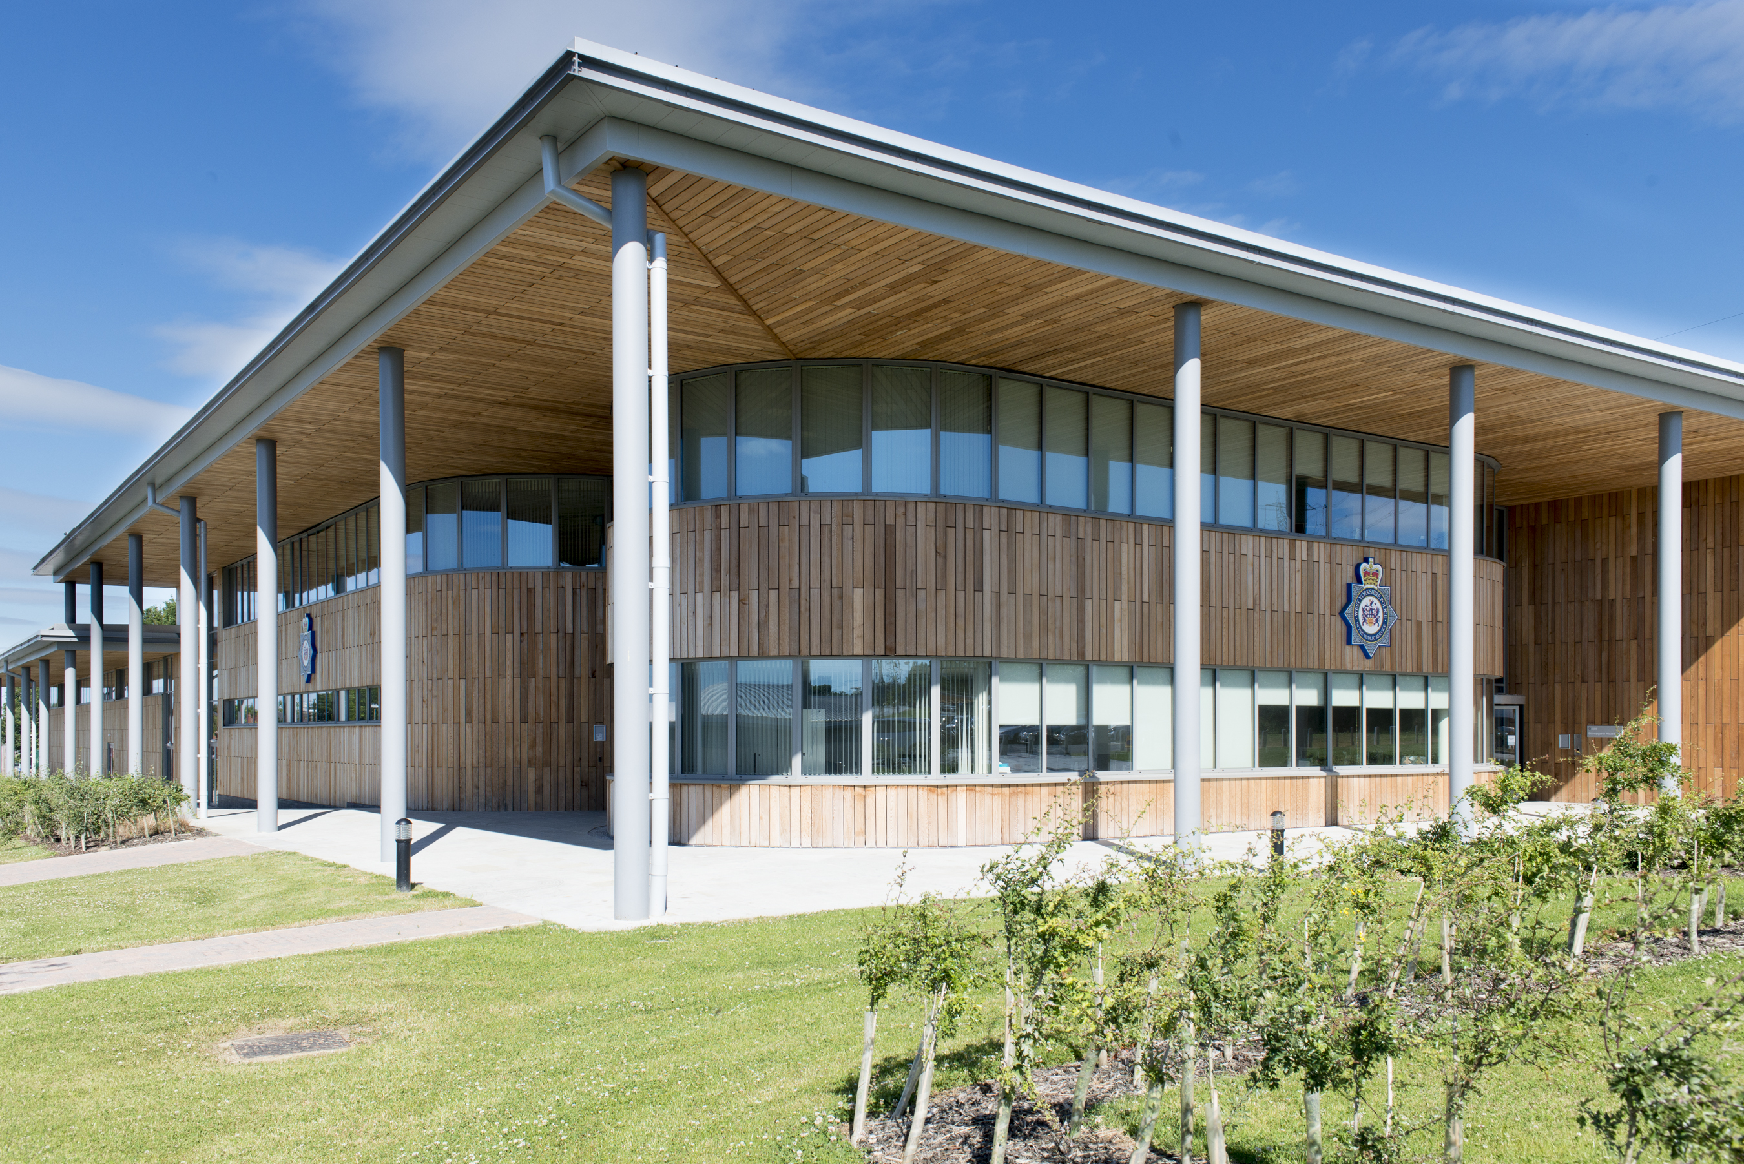

Dates: Monday 21st August to Friday 25th August 2017

** Strictly Limited Places **

Guest Speakers to include:-

Prof. Lorna Dawson - James Hutton Institute, Scotland
Spectral imaging methods to characterise questioned soil samples

Prof. Massimo Tistarelli - University of Sassari, Italy
Face recognition

Dr S. Francese - Sheffield Hallam University, England
Operational use of MALDI MS based methods for fingermark analysis

Dr Martin Baiker, Netherlands Forensic Inst. (NL) - Objective Acquisition & Comparison of 3D Striated Tool- and Firearm Marks

Regional Scientific Support Services Yorkshire and the Humber
(RSSS YatH)

In 2011 the 4 Chief Constables of Yorkshire and the Humber Police Forces shared a vision to deliver Scientific Support Services across the Region as a collaboration. West Yorkshire Police is the lead force for this collaboration. This collaboration was necessary to develop consistent services across the region to become a centre of excellence, whilst achieving improved control of budgets, alignment with national initiatives with a clear vision and line of accountability whilst delivering cashable savings.

The 4 forces areas are: -

- West Yorkshire
- South Yorkshire
- North Yorkshire
- Humberside

Crime Scene Investigation and Forensic Collision Investigation are managed centrally but delivered locally with a number of bases across the region of Yorkshire and the Humber.

Central Services are delivered from the RSSS YatH HQ in Wakefield, West Yorkshire, from a purpose built facility. Central Services include: -

- Imaging Services (with a footprint in Humberside)
- Identification Services
- Forensic Services
- Accreditation and Standards

RSSS YatH has over 450 employees across the region delivering a number of specialist services.

MULTIFORESEE Training School (CA16101 )
Operational CSI and Imaging Techniques

This training school is hosted by one of the end users of the action (Mr N. Denison, MC member, UK). It is designed to fulfil two main aims: -

1) Train the ECIs on the CSI practice of recovering/acquiring, collecting, storing and handling of the evidence (including data protection). This training is paramount to trigger ways to make current or future imaging and multi-modal imaging technologies actually operational by complying with these requirements. Both digital and analytical evidence will be taken in account.

2) Train ECIs on the modern analytical and digital imaging techniques currently used to process the evidence at the crime scene or at crime labs. Strength points and limitations as well as compliance with the Law requirements for evidence handling at all stages will be illustrated.

This tool will contribute towards the achievement of GPs 1 and 9 and to the Secondary Objective 4 (Capacity Building). There will be both theoretical and practical sessions. There will be a total of 6 trainers (for 10 trainees) - 4 of which belong to this Action's MC as full members or substitutes.

MULTIFORESEE Training School (CA16101 ) Timetable -Operational CSI and Imaging Techniques -21/25 Aug 2017

Monday | Tuesday | Wednesday | Thursday | Friday
Carr Gate | Carr Gate | Calder Park - Top Floor | Carr Gate | Calder Park - Top Floor
Introduction Evidence types, Locards Law | Spectral Imaging | Imaging Unit | Packaging exercise | SSU Tour
BREAK | BREAK | BREAK | BREAK | BREAK
DNA - ISO, contamination, Para DNA | Face Recognition | Imaging Unit | Practical fingerprint and footwear | SSU Tour
LUNCH | LUNCH | LUNCH | LUNCH | LUNCH
Transforming Forensics - mobile date | Fingermark Analysis - MALDI MS | Imaging Unit | Practical Vehicle Examination | SSU Tour
BREAK | BREAK | BREAK | BREAK | BREAK
Practical swabbing and trace evidence recovery | 3D Striated Tool- and Firearm Marks | Imaging Unit | Practical Burglary examination | Questions and Answer session and close

COST Action speakers abstracts

The use of spectral analysis methods to characterise soil as physical trace evidence.
Prof. L. Dawson
The James Hutton Institute, Scotland, UK

Soil is increasingly used in criminal investigations as a trace evidence type and also used for intelligence to help investigators ascertain provenance. Soil colour is one of the most easily measured and cheapest characteristics of the available methodologies to use. It involves minimal preparation, can be used at a scene and there are several available relevant databases which can be used to test any comparability between a soil recovered from a questioned item and soil at a crime scene.

Results will be presented that uses the classic but semi quantitative Munsell colour charts, quantitative but portable Minolta spectrophotometry, a simple smartphone Cube system, and a highly sophisticated Dome system. Samples were analysed from a range of land use and geological parent materials and the ability to discriminate between soils was tested using this range of methods. Case samples were included in the data set to test their direct applicability to case work. Important wavelengths for discrimination were identified. This work will hopefully inform the application of such approaches to other physical evidence such as blood.

2D and 3D Face Recognition
Prof. Massimo Tistarelli
Università di Sassari, Italy
Automatic face recognition has attracted the attention of scientists, investors, government agencies as well as the media for the great potential in many application domains. In fact, among the many developed techniques for biometric recognition, face analysis seems to be the most promising and interesting modality.
This lecture will focus on the current state of the art in face recognition technologies and its perspectives, also considering the studies pertaining human visual perception. The human visual system certainly provides a remarkable benchmark for face recognition, but also an inspiration for algorithmic design. The ability of the human visual system of analysing unknown faces, even viewed under different vantage points and to extract different personal features, is an example of the amount of information which can be extracted from face images. This is not limited to the spatial or spatial-frequency domain, but it heavily involves the time evolution of the visual signal. Nonetheless, there are still many open problems which need to be “faced” as well. This not only requires to devise new algorithms but to determine the real potential and limitations of existing techniques, also exploiting the time dimensionality to boost recognition performances.
This lecture will review several methods for face matching, based on diverse similarity measure and image representations, both in 2D and 3D. Some new methods are described, tested with conventional and also new databases from real working environments.

Criminal profiling through MALDI MS based technologies applied to latent fingermarks

Dr. Simona Francese
Sheffield Hallam University, Italy
Fingerprints still remain one of the most powerful means of biometric identification. However, ridge pattern physical information may occasionally be insufficient to match a suspect with a record in the National database; such instances are partial, distorted or smudged marks, fingertips' extensive scarring/abrasion or record absence of the suspect prints. In all of these situations it is very desirable to have a technology able to provide additional intelligence from a fingermark exploiting its endogenous and exogenous molecular make-up.
In recent years Matrix Assisted Laser Desorption Ionisation Mass Spectrometry Imaging (MALDI MSI) has proven its ability to provide multiple images of the same fingermark simultaneous with additional intelligence. The opportunity to detect chemical information (aminoacids, fatty acids, peptides, proteins, drugs, toiletry products, condom lubricants as a few examples) could provide investigative leads on the suspect's lifestyle and activity prior to leaving the mark. In a recent publication, for example, we demonstrate that it is possible to determine the sex of the donor through detection of peptides from their fingermark with high level of accuracy. In a more recent publication, we report on the opportunity to reliably detect and map the presence of blood onto the identifying ridges of a fingermark, thus providing associative evidence between the events of the bloodshed and the biometric information.
Here, the pioneering use and rapid developments of MALDI MS and MSI for the analysis of latent marks are presented together with insights into Police casework undertaken in collaboration with the West Yorkshire Police in UK.

Objective Acquisition & Comparison of 3D Striated Tool- and Firearm Marks
Dr. Martin Baiker
Netherlands Forensic Institute, Netherlands
The traditional approach for comparing tool- or firearm mark evidence is to use a comparison microscope. Two marks are put side by side and features in the marks, e.g. striations, are accentuated using oblique light. The result is a light-shadow pattern, representing the actual toolmark topography. The forensic expert then performs a visual comparison of the two illumination patterns, tries to identify matching features and judges the strength of the evidence. This approach includes subjectivity in the process and thus may lead to varying results among examiners. The two main reasons are that the true 3D topography of an object is judged using a 2D imaging technique (comparison microscopy), including the manual adjustment of the lighting conditions, a limited depth of focus and missing information in shadow areas, and that judging the evidence is dependent on the experience of the examiner. This presentation will demonstrate several possibilities to render casework more objective and to reduce the variability of examination results. An introduction to 3D mark topography acquisition will be given as an alternative to 2D microscopy and several examples of cases will be shown, in which the usage of 3D technology was crucial. In addition, an automated tool- and firearm mark alignment method and a way to calculate the strength of the evidence, the Likelihood Ratio, using digital databases will be presented. Furthermore, a demonstration of the software package Scratch, developed at the Netherlands Forensic Institute that can be used for automated mark alignment and LR calculation, will be given.

Application form
Name…………………………….…………………..Surname…………………………………………

Institution/Industry/End User Name ……………………………………………………….

Country………………………………............................................................................
Early career investigator - Provide justification that you fit the definition for ECI*: ……………………………………………………………………………………………………………………………………………………………………………………………………………………………………………………………………………………………………………………………………………………………
Expertise: ………………………………………………………………………………………………………………………………………………………………………………………………………………………………………………………………………………………………………………………………………………………………………………………………………………………………………………………………………………
Qualifications
……………………………………………………………………………………………………………………………………………………………………………………………………………………………………………………………………………………………………………………………………………………………………………………………………………………………………………………………………………………………..
According to COST definitions, ECI are individuals whose career spun less than 8 years between the date of the PhD/doctorate (or similar experience) and the date of involvement in the COST Action. Periods of career leave have to be added to this time span.

…………………………………………………………………………………………………………………………………………………………………………………………………………………………………………………………...…………………………………………………………………………………………………………………………………………………………………………………………………………………………………………………………………………………………………………………………………………………………………………………………………………………………………………………………………………………
Reasons for applying
………………………………………………………………………………………………………………………………………………………………………………………………………………………………………………………………………………………………………………………………………………………………………………………………………………………………………………………………………………………………
Additional documents
- CV
- For PhD students only - Attach a reference/support letter from your Supervisor (on headed paper and signed)
Please only send the application form (pages 6 and 7 in this document) and the requested documents, NO LATER than June 5th 2017 by close of business to:
Dr Simona Francese, CA16101 Action Chair - s.francese@shu.ac.uk
Applications will be reviewed by 2 members of the Core group in addition to the host Mr Neil Denison from West Yorkshire Police.
Results will be communicated to the applicant, no later than June 20th 2017

